UEN Legislative Update
April 22, 2021

In this UEN Weekly Report from the 2021 Legislative Session, find information about:
- Budget Bills Status in Both Chambers
- School Choice Updates
- Education Bills Pending and Bills on the Move
- Advocacy Checklist for This Week
Budget Bills Status in Both Chambers
The IALNS Newsletter reported the progress of budget bills required to be completed before the end of the 2021 Session. The House’s Education Appropriations bill, HF 868, is on the Debate Calendar for Monday, April 26. See the April 15 weekly report for details of HF 868. As budget bills progress, the close of the 2021 Session is within sight. Daily per diem for legislators ends on April 30, which is the 100th day of the Session. It may be a stretch for them to finish all on their plate by then.
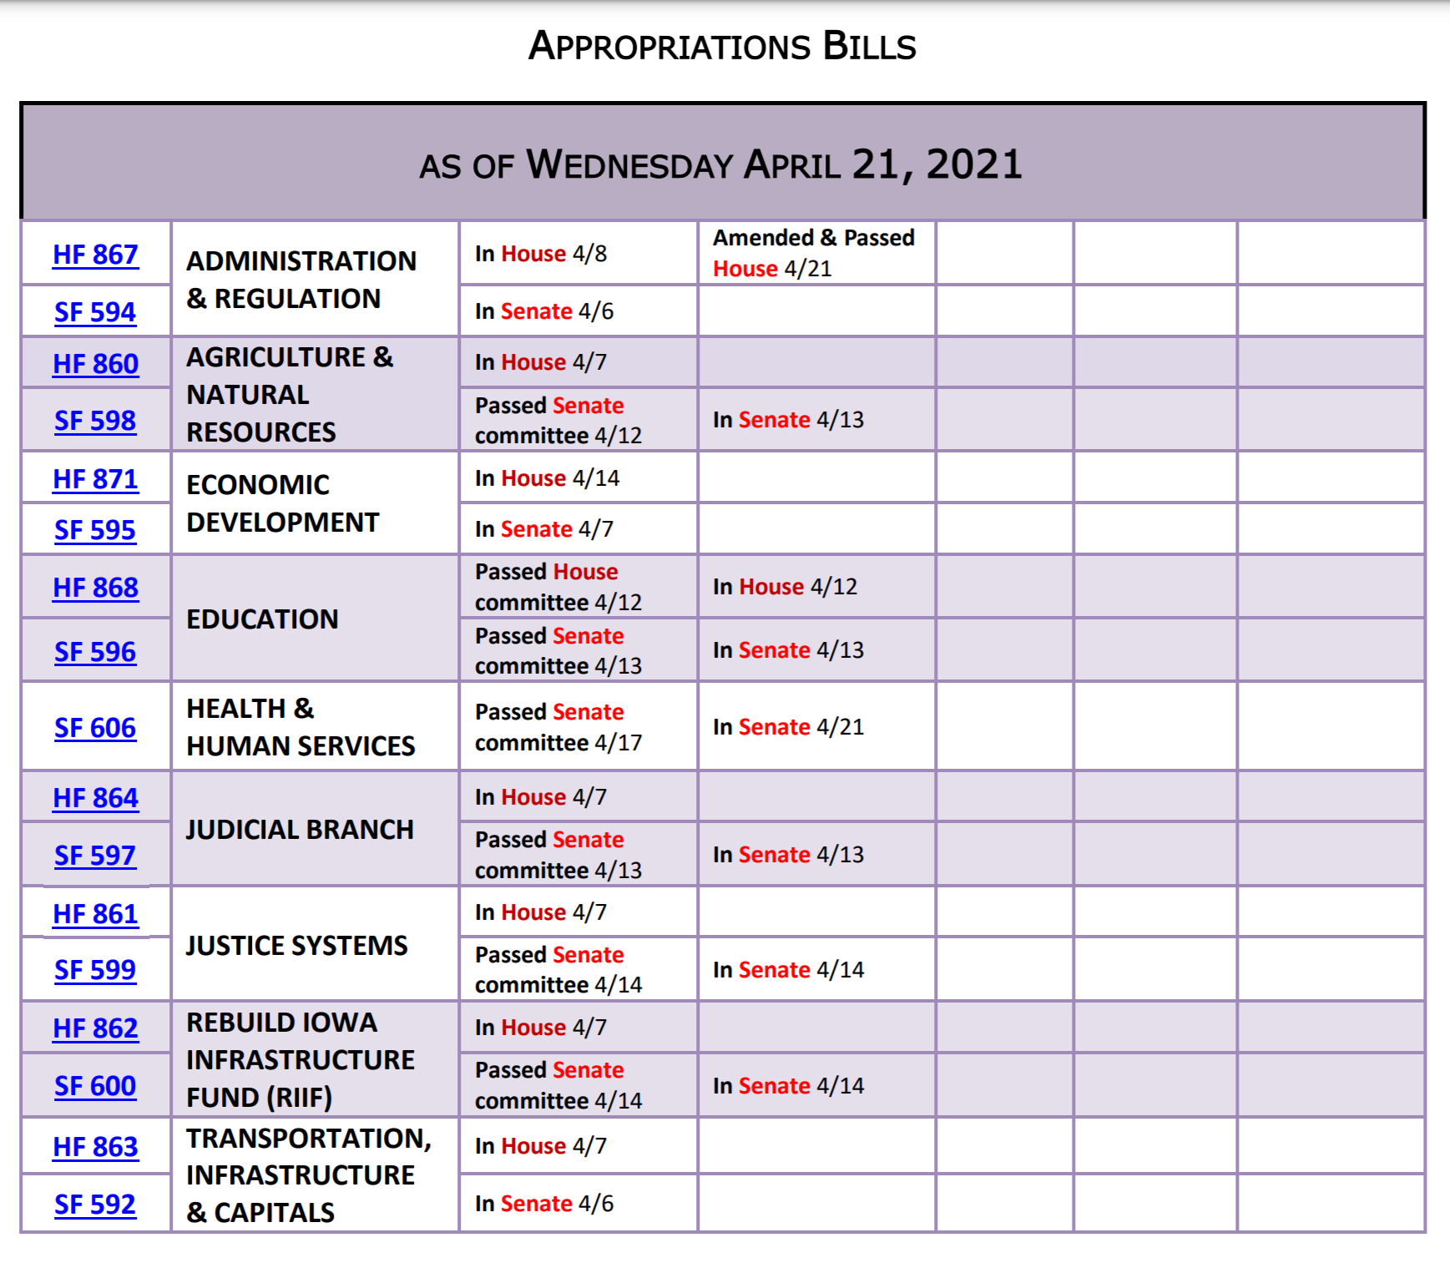

School Choice Updates: SF 159 School Choice included Students First Scholarships (vouchers), elimination of open enrollment regulation via Voluntary Diversity Plans, Charter Schools, Tuition and Textbook Tax Credits and Other Education Practices and Flexibility. That bill was approved very early in the Session, in the Senate, on mostly party lines, with Republican Senators Shipley and Sweeney voting with the Democrats. The Iowa House carved the big bill up into several different pieces of legislation. Here’s the latest on status of the various school choice provisions:
- HF 228 Diversity Plans/Open Enrollment: The House agreed to the Senate Amendment this week, sending it to the Governor. For the 2021-22 school year, there is no deadline to open enroll out of a district with a voluntary diversity plan on July 1, 2020. The March 1 deadline will apply for the 2022-23 school year and going forward. UEN is opposed to this bill.
- HF 813 Charter Schools: This bill is on the Senate Calendar with amendments unlikely (public records and other provisions are now amended on to HF 847 Education Practices and Flexibility). UEN is registered opposed to this bill. Rationale: 1) the founding group is not required to be Iowans, 2) if a student leaves the charter school there is no provision to pay prorated funds back to the school district, and 3) Charter Schools can be created in school districts without the approval of the school board. We did support application of Chapter 22 Public Records to the charter schools and are supportive of that amendment provision.
- HF 847 Education Provisions and Flexibility: Details of this bill are outlined below, but it basically includes the FS3 (Flexible School and Student Support) Program, expansion of tax credits, changes to open enrollment and changes to operational sharing incentives. UEN is undecided on this bill.
- Vouchers: There is still no sign of any voucher bill moving in the House, but there is a $3 million line-item appropriation in the Senate’s Education Appropriations Bill, SF 596, signaling that the Senate (and Governor) have not given up their push for vouchers in Iowa. Watch your inboxes as the Session winds down, in case a last-minute call to action is required.
Education Bills Still Pending: In addition to passing a budget, consensus on tax policy changes and other heavy lifts still on the statehouse agenda is pending. Here are several education bills we are still watching:
- HF 532 Qualified Instructional Supplement: This bill is on Senate Agenda with amendment (includes PK fed funding). UEN opposes the original bill but supports the Senate Appropriations Committee Amendment.
- HF 602 General Fund Transfer to Student Activity Fund: This bill provides a short time for districts to transfer general funds to the student activity fund if revenues were hampered by the pandemic. It is on the Senate Calendar. UEN supports this bill.
- HF 744 Protecting Free Speech: This bill was amended in the Senate to include a provision regarding staff in charge of school newspapers and protecting student free speech, sending it back to the House. UEN supports this bill.
- HF 802 Diversity Training: This bill is on Senate Calendar expecting amendment. UEN is registered as undecided (leaning opposed), hoping to get the amendment to remove the application of these restrictions on curriculum.
- HF 318 PK for young 5s: This bill would allow districts to serve and count young five-year-olds in the statewide voluntary preschool program as a local control decision, however, the PK program is required to prioritize four-year-olds if there is limited space. It is on the Senate Calendar. UEN is registered in support.
- SF 265 Parent Request to Retain: This bill allows a parent to request their student repeat a grade, due to lack of progress related to the pandemic year, with the request due by Aug. 15, 2021. That date is too late, so we are advocating for June 1 or the last day of school, whichever is later. Rep. Wheeler, floor manager of the bill, is open to amending the date if the bill moves, but it may not advance this year. UEN is registered as undecided.
Bills on the Move
- SF 532 Behavior Analysts and Mental Health Counselors: This bill requires BOEE to establish a statement of professional recognition and/or Certification for these two positions. The Senate Concurred with the House amendment, 46:0, sending it to the Governor. UEN supports this bill.
- HF 675 Substitute Teacher Authorizations: Allows a person to be a substitute teacher with an AA degree or the completion of 60 credit hours of college for up to 10 consecutive days in one position. Allows the appointment for a 10-day period within a 30-day period but allows schools to file with the state BOE for an extension of an appointment due to documented need and benefit to the program. Approved by the Senate, 46-0, sending it to the Governor. UEN supports this bill.
- HF 770 Licensure Renewal Requirements: Requires the BOEE to allow that half of the units needed to earn license renewal by a teacher can be done through an individualized PD plan or by completing courses offered by a PD program licensed by the BOEE or an AEA. Approved by the Senate, 46-0, sending it to the Governor. UEN supports this bill.
- HF 793 PE Credits for ROTC students: Exempts a student in Junior ROTC from PE requirements and gives the student 1/8 unit credit for PE for each semester the student is in Junior ROTC. Approved by the Senate, 46-0, sending it to the Governor. UEN supports this bill.
- HF 847 Education Practices and Flexibility: This bill originated from the Governor’s Education Choice and Flexibility Policy, much of it included in SF 159, but has been heavily amended. UEN is registered as undecided on the bill. We opposed the expansion of the Tuition and Textbook Tax Credits and have concerns about some of the open enrollment provisions but support the expanded flexibility. The bill includes the following:
  - Flexibility: creates a Flexible Student and School Support Program (FS3) allowing schools to implement evidence-based practices for innovative ways to improve student learning in exchange for the waiver of regulations. Adds Teacher Leadership and Compensation (TLC) ending balances as transferable to the school’s flexibility account, for use to fund the FS3 or any other allowable use of the flexibility account. Requires unobligated Teacher Salary Supplement (TSS) funds in excess of a 5% carry forward to be paid to eligible teachers/certified staff by July 1, 2022.
  - Tax Credits: Allows homeschoolers to use the Tuition & Textbook tax credit. Increases the credit to 25% of the first $2,000. Allows teachers to take a state tax credit similar to the federal credit for expenses. This provision is estimated to cost the state general fund around $12 million.
  - Open Enrollment:
    - Makes changes in the custody/residence of the child and that the child’s school is in need of significant improvement as good cause for missing open enrollment deadlines.
    - Makes the deadline for pre-K students needing special education as Sept. 1.
    - Makes denials related to the inability of a school to meet a student’s need appealable to the state BOE.
    - Increases the eligibility of transportation assistance for open enrollment to be determined by the State BOE, to at least 200% of the federal poverty level (currently the FP is 185% which is the ceiling for free and reduced price lunch eligibility.)
  - Open Enrollment Athletic Eligibility: Allows open-enrolled students to participate immediately in sports if sports have been suspended in the original district but maintains ineligibility if the student is ineligible for academic reasons. Makes the 90-day period of ineligibility 90 calendar days. Allows the boards of both school districts to waive the ineligibility period. Includes special provisions allowing the waiver of ineligibility periods for students who changed schools in the FY 2020-2021 school year. The Ways and Means Committee approved an amendment making some changes to these provisions. The amendment is not yet available, but we will report on it when it is published.
  - Weighting: Adds work-based learning coordinators and special education directors to positions that can generate operational shared weighting (3 students each). Reduces the supplemental weighting for some of the operational sharing positions in FY 2022-2024 (lowers a 5 weighting to a 4 and lowers a 3 weighting to a 2).
  - Ways and Means Committee Amendment: Strikes some of the athletic eligibility changes. Allows a principal to waive rules on face masks if in the best interest of a child. Includes restrictions on charter schools in HF 813 (applying Chapter 22 Public Records, for example). Amended and Passed 15:0, which moves the bill to the Senate Calendar.
- Senate Confirmations: Congratulations to Dir. Ann Lebo, confirmed by the Senate as Director of the Department of Education! Marsha Tangen was originally recommended to be appointed by the Governor to the School Budget Review Committee (SBRC), but her name was withdrawn. That leaves an opening for a Republican woman on the SBRC needed to achieve the gender and political balance required by state law. If you know someone who would be interested, they should contact the Governor’s office.
Advocacy Checklist this Week in the Senate
- HF 802 Diversity Training Restrictions, needs amending in the Senate to remove any restrictions on curriculum, which is the purview of the school board. Contact your senators and ask for their action to amend the bill accordingly.
- HF 532 Qualified Instructional Supplement and PK Enrollment Growth Fix: Ask your Senator for a Yes vote on Senate Appropriations Committee Amendment which improves the distribution formula based on students served, and provides an SBRC process for funding and spending authority for increased preschool students in the Fall of 2021. If your district receives a little less per pupil than others with larger Title I/poverty enrollment, let your Senator know that this distribution formula with state funds ($27.2 million) will help to achieve balance and provide the resources necessary to schools helped less by the federal money, however, still incurring significant COVID-19 expenses.
- Vouchers: Remind legislators one more time that public money should not fund private interests, that public money requires transparency not found in the Governor’s voucher plan, and Iowa families and students already have school choice through open enrollment, public virtual schools, school tuition organization tax credits which support low-income families with private school tuition and two kinds of home school. Vouchers are not for Iowa.
- Gratitude: Pick one bill sent to the Governor that will help your district, and tell your legislators
THANK YOU for getting that done.
Connecting with Legislators:
Find biographical information about legislators gleaned from their election websites on the ISFIS site here: http://www.iowaschoolfinance.com/legislative_bios Learn about your new representatives and senators or find out something you don’t know about incumbents.
Find out who your legislators are through the interactive map or address search posted on the Legislative Website here: https://www.legis.iowa.gov/legislators/find
To call and leave a message at the Statehouse during the legislative session, the House switchboard operator number is 515.281.3221 and the Senate switchboard operator number is 515.281.3371. You can ask if they are available or leave a message for them to call you back.
Advocacy Resources:
Check out the UEN Website at www.uen-ia.org to find Advocacy Resources such as Issue Briefs, UEN Weekly Legislative Reports and video updates, UEN Calls to Action when immediate advocacy action is required, testimony presented to the State Board of Education, the DE or any legislative committee or public hearing, and links to fiscal information that may inform your work. The latest legislative actions from the statehouse will be posted at: www.uen-ia.org/blogs-list. See the UEN Advocacy Handbook linked here, which is also available from the subscriber section of the UEN website
Thanks to our UEN Corporate Sponsors:
Special thank you to your UEN Corporate Sponsors for their support of UEN programs and services. You can find information about how these organizations may help your district on the Corporate Sponsor page of the UEN website at https://www.uen-ia.org/uen-sponsors.
www.boardworkseducation.com

Contact us with any questions, feedback or suggestions to better prepare your advocacy work:
Margaret Buckton
UEN Executive Director/Legislative Analyst
margaret@iowaschoolfinance.com
515.201.3755 Cell

